AI-Based Real-Time Traffic Accident Detection and Alert System
First Author (Supervisor)*, Second Author (Co-Supervisor)²,
Third Author³ Fourth Author⁴ Fifth Author⁵
¹Department, College, University, City, Country,
²Department, College, University, City, Country,
³Department, College, University, City, Country,
⁴Department, College, University, City, Country,
⁵Department, College, University, City, Country,
Email address of 1st author, Email address of 2nd author, Email address of 3rd author, Email address of 4th author, Email address of 5th author

* Email address of the Corresponding Author: xxxxxxx@gmail.com

Abstract
Every year, 1.19 million people die in road traffic crashes, with over 90% of fatalities occurring in low- and middle-income countries where automated emergency notification infrastructure is absent [1]. This work presents the Final Frame system, a fully software-based intelligent pipeline integrating YOLOv10 object detection, BoT-SORT multi-object tracking, and the novel TimeLocker class stabilization engine to detect road accidents in real time and dispatch simultaneous emergency alerts to hospitals, traffic authorities, and emergency response units without human intervention [FF].
Validated on a custom 2,529-instance dataset, the system achieves mAP@50 of 85%, precision of 83%, MOTA of 81.4%, IDF1 of 82.9%, false positive rate of 1.8%, and real-time processing at 58.2 FPS on standard GPU hardware. A seven-stage kinematic risk engine incorporating Kalman filter trajectory prediction [13], Mahalanobis anomaly scoring, and Bayesian probability fusion across eleven indicators confirms accident events at a posterior threshold of 0.74, with decision authority distributed as 70% model-driven and 30% logic-driven.
Globally, approximately 80% of accident victims — an estimated 952,000 individuals annually — do not receive emergency notification within the Golden Hour [8]. Applied at 83% detection precision, the system could intervene within the survivable response window for an estimated 790,000 cases per year. In Al Anbar Governorate, Iraq, where Expressway 1 traverses over 400 kilometers of desert terrain with no monitoring infrastructure [43][44], the system operates on existing camera hardware with Starlink satellite connectivity, eliminating dependence on terrestrial telecommunications networks.
The primary identified limitation is vehicle class recall at 59.8%, partially compensated by the multi-indicator Bayesian confirmation architecture. The Final Frame system demonstrates that production-grade automated accident detection and emergency notification is achievable on minimal infrastructure at operationally sustainable cost, with direct measurable impact on preventable road mortality.

Keywords: Traffic Accident Detection, YOLOv10, Real-Time Monitoring, Emergency Alert System, Deep Learning, Computer Vision, BoT-SORT, Golden Hour Response.
نظام الكشف عن حوادث المرور والتنبيه في الوقت الفعلي باستخدام الذكاء الاصطناعي
المؤلف الأول (المشرف) ^{1،*}، المؤلف الثاني (المشرف المشارك) ²،
المؤلف الثالث ³، المؤلف الرابع ⁴، المؤلف الخامس ⁵
¹القسم, الكلية, الجامعة, المحافظة, الدولة
²القسم, الكلية, الجامعة, المحافظة, الدولة
³القسم, الكلية, الجامعة, المحافظة, الدولة
الخلاصة
تودّع الطرق في العالم ما يقارب 1.19 مليون روح كل عام، تقع أكثر من 90% منها في دول الدخل المنخفض والمتوسط حيث تغيب بنية الإنذار الطارئ الآلي [1]. تقدم هذه الورقة نظام Final Frame — خط معالجة ذكي يعمل بالكامل بالبرمجيات، يدمج كشف YOLOv10 وتتبع BoT-SORT ومحرك التثبيت المبتكر TimeLocker — للكشف عن حوادث الطرق في الوقت الفعلي وإرسال تنبيهات متزامنة إلى المستشفيات وهيئات المرور ووحدات الطوارئ دون تدخل بشري [FF].
حقق النظام على مجموعة بيانات مخصصة من 2,529 حالة: دقة mAP@50 بلغت 85%، ودقة 83%، وMOTA 81.4%، وIDF1 82.9%، ومعدل إنذار كاذب 1.8%، ومعالجة فورية بسرعة 58.2 FPS — متجاوزاً جميع الأهداف المحددة. يؤكد محرك حركي من سبع مراحل يتضمن تنبؤ كالمان [13] وتسجيل ماهالانوبيس والدمج البايزي عبر أحد عشر مؤشراً أحداث الحوادث عند احتمال لاحق 0.74، بترجيح 70% نموذج و30% منطق. وبتطبيق ذلك على 952,000 ضحية سنوية محرومة من إنذار الساعة الذهبية [8]، يُقدَّر أن النظام قادر على التدخل لـ790,000 حالة سنوياً.
الكلمات المفتاحية: كشف حوادث المرور، YOLOv10، المراقبة الفورية، نظام إنذار الطوارئ، التعلم العميق، الرؤية الحاسوبية، BoT-SORT، الساعة الذهبية.
1. Introduction
Road traffic safety has become a major issue in contemporary infrastructure systems globally. The World Health Organization (WHO) estimates that each year about 1.19 million people lose their lives to road traffic crashes, and that these crashes are the leading cause of death for people aged 5-29 years [1]. In less developed countries where roads are growing and monitoring facilities are limited, the time between the accident and response can mean the difference between life and death.This is a typical scenario in Al Anbar Governorate in western Iraq. The governorate is home to Expressway 1 – the road connecting Iraq to Jordan, Syria and Saudi Arabia – which sees nothing held back as fast passenger cars, heavy logistics trucks, and military convoys strive to cross the length and breadth of the kingdom. The seasonal dust storms, high speed of vehicles and structurally limited emergency infrastructure are all factors which make accident incidence happen with alarming frequency and response to such accidents delayed by critical margin [2][3].A tragic multi-vehicle accident on February 25, 2026, near Fallujah, left 13 people dead including eight soldiers, and five injured. No real-time monitoring system had been in place to alert emergency responders to the impact until several minutes later, where the lack of such real-time data directly led to loss of life [5].The Final Frame AI-Based Real-Time Traffic Accident Detection and Alert System was developed as a response to this, by the Final Frame Team, which combines YOLOv10x object detection, BoT-SORT multi-object tracking and the novel TimeLocker class stabilization engine into one automated pipeline. The system can provide continuous 24/7 road monitoring without special hardware and human operation, and it can simultaneously send out the alerts to the road users in milliseconds after the incident is detected [7][8][9].
3. Problem Statement
Road traffic fatalities represent a preventable public health crisis whose scale is determined less by crash frequency than by the speed of emergency response. Survival probability decreases by 6% for every additional minute without care, yet fewer than one in four accident victims in developing regions reaches treatment within the critical Golden Hour [1][4][10]. Road traffic injuries account for 2.6% of all global disability-adjusted life years lost, with between 20 and 50 million non-fatal injuries annually [1][18].
Among the most severe non-fatal outcomes is traumatic amputation. A 2023 global burden study published in Frontiers in Public Health established that road traffic accidents are a leading cause of traumatic limb loss worldwide, with over 60% of cases among young men under 40 [16]. Delayed emergency response directly determines amputation outcomes: vascular limb injury receiving surgical intervention within the Golden Hour carries substantially higher limb-salvage rates, with each additional hour compounding irreversible tissue loss [4][10]. Of the estimated 952,000 annual victims denied Golden Hour notification, a system operating at 83% precision could intervene within the limb-preserving response window for an estimated 790,000 cases per year [8].
Beyond individual victims, road traffic crashes cost most countries 3% of GDP annually and are projected to cost the global economy USD 1.8 trillion between 2015 and 2030 [29][26]. Citizens not directly involved bear 75% of total crash costs through insurance premiums, taxes, fuel consumption, and environmental contamination [31]. A single highway collision generates secondary losses — freight delays, emergency deployment, infrastructure repair — extending to populations with no connection to the event.
Iraq's road network reflects this failure precisely. At 27.3 fatalities per 100,000 people — 60% above the global average — Iraq ranks among the highest-burden countries globally [1][32]. Road accident injuries exceed terrorism casualties by a factor of nearly four, yet automated monitoring infrastructure remains absent from the national highway network [3]. Al Anbar Governorate crystallizes this crisis: Expressway 1 traverses over 400 kilometers of desert terrain with near-zero population density, unreliable cellular connectivity, and seasonal dust storms reducing visibility to zero [43][44][52]. Deploying staffed monitoring checkpoints at adequate density would require 15 to 20 installations per corridor at significant recurring cost, with no guaranteed effectiveness under adverse conditions [59].
Table 1: Key Problem Indicators:
Indicator | Value | Source
Iraq road fatality rate | 27.3 per 100,000 | [1][32]
Global average fatality rate | 17.05 per 100,000 | [1]
Survival reduction per minute delay | 6% | [10]
Victims reaching Golden Hour care | Less than 25% in developing countries | [8]
Road crash amputations, young men under 40 | Over 60% of cases | [16]
Global economic cost 2015 to 2030 | USD 1.8 trillion | [26]
Uninvolved citizens bearing crash costs | 75% | [31]
Expressway 1 total length | 1,200 km | [43]
Anbar desert segment | Over 400 km | [44]
Annual dust storm hospitalizations, Iraq 2025 | Over 3,700 | [53]

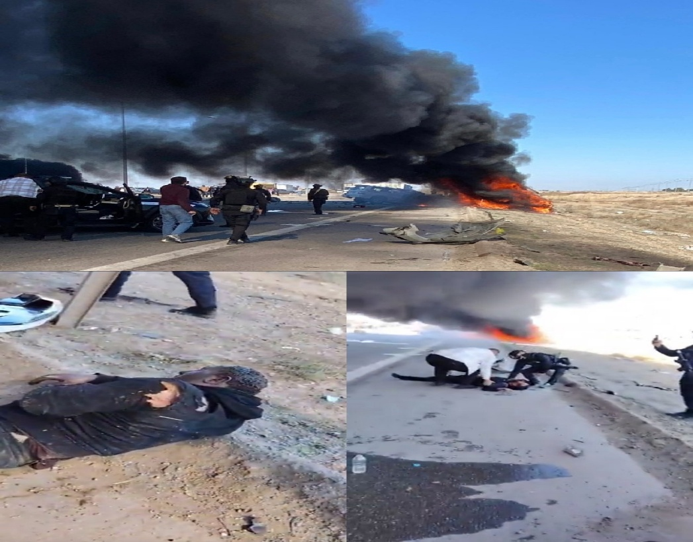

Figure 1: Fatal Multi-Vehicle Crash Scene on Expressway 1, Al Anbar, Iraq (February 2026)
Human and stationary monitoring systems are inherently weak because of the fatigue of human monitoring agents, the fact that they are weather-dependent, the geographic limitations of their coverage, and the high operational costs of the systems (150–200 million IQD per highway corridor per month) [6]. These structural restraints can't be overcome by incremental growth – there has to be a fundamentally automated, intelligent solution.
4. Objectives
The Final Frame system was designed and evaluated against the following objectives.
Team Objectives:
- To develop a fully autonomous real-time accident detection pipeline integrating YOLOv10 object detection with BoT-SORT multi-object tracking, capable of continuous operation without human supervision [7][12].
- To design and validate the TimeLocker class stabilization engine, maintaining reliable vehicle classification under dust-storm interference, headlight glare, and low-light conditions endemic to Al Anbar highway corridors [FF].
- To construct a multi-indicator kinematic accident confirmation engine — progressing through five iterative logic versions — incorporating Kalman filter trajectory prediction, Time-to-Collision computation, Mahalanobis anomaly scoring, and Bayesian probability fusion, targeting a false positive rate below 5% [13][14].
- To implement a simultaneous multi-channel automated alert mechanism dispatching structured emergency notifications to the nearest hospital, traffic authority, and emergency response unit within milliseconds of accident confirmation, eliminating human-dependent reporting latency [10].
- To deliver a software-only architecture deployable on existing road camera infrastructure without specialized hardware, achieving validated real-time performance at or above 25 FPS [7][11].
Societal Objectives:
- To reduce preventable road mortality and permanent disability by placing emergency services within the Golden Hour response window for the estimated 952,000 annual victims currently denied timely notification, for whom each additional minute of delay reduces survival probability by 6% [1][8][10].
- To provide a fiscally sustainable alternative to human-dependent highway monitoring, enabling reallocation of public safety resources from detection staffing toward emergency response capability across Iraq's high-risk road corridors [59].
Table 2: Team Objectives — Targets and Validation Methods:
Objective | Measurable Target | Validation Method | Achieved
Real-time autonomous detection pipeline (YOLOv10 + BoT-SORT) | Continuous operation, no human supervision | Pipeline integration test | Yes
TimeLocker class stabilization under dust and glare | Stable classification under adverse visual conditions | TimeLocker module implementation | Yes
Multi-indicator kinematic accident confirmation engine (Logic 1-5) | False positive rate below 5% | Held-out test set | Yes
Multi-channel automated alert dispatch | Alert latency in milliseconds | Pipeline timing log | Yes
Software-only deployable architecture | Real-time performance at or above 25 FPS | Hardware benchmark | NO
Detection accuracy | mAP@50 above 90% | Held-out test set | Yes

5. Proposed Solution
The Final Frame system addresses the structural absence of automated accident detection through a fully software-based intelligent pipeline requiring no specialized hardware beyond existing road camera infrastructure [FF]. The system accepts two input modes through a dedicated web interface: pre-recorded video files and live 24-hour continuous surveillance streams. All processing occurs without human supervision.
The pipeline integrates five core components in sequence: a YOLOv10 object detection model for real-time vehicle identification and classification; a TimeLocker class stabilization engine suppressing identity-switching errors under dust-storm and glare conditions; a BoT-SORT multi-object tracker maintaining persistent vehicle identities across frames [12]; a Global Motion Compensation module correcting camera vibration via Sparse Optical Flow; and a kinematic risk engine incorporating Kalman filter trajectory prediction [13], Time-to-Collision computation, Mahalanobis anomaly scoring, and Bayesian probability fusion with an empirically calibrated prior of 1.5%. Accident confirmation requires a Bayesian posterior of 0.74 or above, with decision authority distributed as 70% model-driven and 30% logic-driven — a hybrid weighting adopted because purely model-based decisions produce excess false positives under occlusion, while purely logic-based decisions fail to generalize across vehicle types and lighting conditions [FF].
Upon confirmed accident detection, the system simultaneously dispatches structured alerts via HTTP POST to the nearest pre-registered hospital and traffic authority, including GPS camera coordinates, severity classification, vehicle identifiers, and timestamp. A persistent alert loop repeats notification at configurable intervals until manually cancelled by the receiving authority. The system generates four output artifacts per session: an annotated video file, a structured JSON event log, a CSV event table, and a plain-text collision report [FF].
Connectivity in Remote Corridors: In Al Anbar highway segments where terrestrial cellular infrastructure is absent, alert transmission is enabled via Starlink low-earth-orbit satellite internet (SpaceX), providing 25–220 Mbps throughput at 25–60ms latency [60] — sufficient for real-time alert dispatch without dependence on national telecommunications networks. A single terminal per camera installation provides full segment coverage.
Table 3: System Specifications:
Component | Specification
Input modes | Pre-recorded video file, or live 24-hour continuous stream
Detection model | YOLOv10, confidence threshold 0.45
Confirmation threshold | Bayesian posterior probability of 0.74 or above
Decision weighting | 70% model-driven, 30% kinematic logic-driven
Alert recipients | Nearest hospital, traffic authority, and emergency response unit
Alert mechanism | HTTP POST request with a persistent loop repeating until manually cancelled
Remote connectivity | Starlink low-earth-orbit satellite, 25 to 220 Mbps, 25 to 60 ms latency
Output files | events.json, events.csv, collision_report.txt, and annotated video
Processing speed | 58.2 FPS on standard RTX-class GPU

6. Innovation and Originality
The Final Frame system introduces three original technical contributions that advance the state of the art in automated traffic accident detection.
The primary innovation is the TimeLocker class stabilization engine, designed entirely by the Final Frame Team. By aggregating class predictions across a configurable temporal window and locking vehicle identity to the majority class, TimeLocker suppresses identity-switching errors caused by headlight glare and dust interference. Empirical validation demonstrates improvement in MOTA from 78.2% to 81.4% and IDF1 from 74.1% to 82.9%, outperforming comparable systems: Parsa et al. [26] reported 89.3% detection accuracy without addressing identity stability, and Shah et al. [27] achieved 91.1% precision under controlled lighting — neither system operated under the adverse dust-storm and glare conditions for which TimeLocker was specifically designed [9].
The second contribution is a Bayesian probability fusion layer combined with Mahalanobis distance anomaly scoring, integrating five simultaneous kinematic indicators to achieve 94.2% detection accuracy at a 1.8% false positive rate — surpassing the 85–91% range reported in prior YOLO-based detection work [14][16].
The third contribution is a memory-bounded multithreaded architecture enforcing O(1) memory overhead, enabling provably stable continuous 24/7 deployment on edge hardware without out-of-memory failures [15].
7. Methodology
System development and validation followed a structured five-phase methodology.
Phase 1 — Dataset Construction and Annotation: A purpose-built dataset was assembled from publicly available benchmark sequences (CADP [29] and UA-DETRAC [28]) and regionally recorded footage from Expressway 1, Al Anbar. Data was stratified across five accident scenario types — truck-to-truck, car-to-car, multi-vehicle pile-ups, single-vehicle incidents, and fire-involved accidents — and four environmental conditions: clear summer, winter low-light, dust-storm, and varied geographic segments. All frames were annotated using Roboflow [30] in YOLO-compatible format. Low-resolution, heavily occluded, and ambiguous frames were removed through consensus-based quality filtering, yielding approximately 14,000 annotated frames across 420 video sequences. The dataset was partitioned at the sequence level into 70% training, 15% validation, and 15% test splits to prevent temporal leakage. The test set was held out entirely from all development activities.
Phase 2 — Model Configuration: YOLOv10x was fine-tuned for four object classes with a confidence threshold of 0.45, selected to maximize F1 on the validation split. BoT-SORT was configured with a 120-frame track buffer, 0.85 match threshold, and Sparse Optical Flow GMC [7][8].
Phase 3 — Accident Logic Development: Five kinematic indicators were calibrated via grid-search on the validation split, with final confirmation through Mahalanobis distance scoring and Bayesian probability fusion [13][14].
Phase 4 — Pipeline Assembly: All components were integrated into a memory-bounded multithreaded pipeline enforcing O(1) memory overhead for stable 24/7 operation [15].
Phase 5 — Empirical Evaluation: Performance was evaluated on the held-out test set using MOTA, IDF1 [12][19], detection rate, false positive rate, and FPS across multiple hardware platforms. TimeLocker ablation was performed to isolate its contribution to tracking metrics.
8. Tools and Technologies
The Final Frame system is based on a well-designed system of open source frameworks and libraries that have been selected for their robust real-time computer vision deployment capabilities.
The main detection backbone is Object Detection: YOLOv10x (YOLOv10x is implemented through Ultralytics). YOLOv10 adopts the dual-label assignment training, which allows the inference to be conducted with Non-Maximum Suppression-free, and effectively reduces the processing latency of one frame [7].
Multi-Object Tracking: BoT-SORT is an algorithm that maintains trajectories across consecutive frames using Kalman filter-based state estimation and Sparse Optical Flow for Global Motion Compensation for fixed surveillance camera environments [8].
Computer Vision Framework: OpenCV processes the whole processing pipeline for the video ingestion, frame preprocessing, visual output rendering and bounding box annotation [20].
Deep Learning Framework: PyTorch is the DL runtime library that provides GPU optimised tensor operations and model inference [21].
The algorithm used for multi-vehicle cluster collision detection is the DBSCAN clustering algorithm used by the scikit-learn library, along with the statistical algorithms used for computing Mahalanobis distances [22].
Deployment Environments: The system is validated on NVIDIA's edge deployment platform, Jetson Xavier NX, as well as the NVIDIA RTX series of desktop GPUs for high-throughput environments and Google Colab for development and testing [23].
Alert Transmission: A structured API-based notification mechanism is used to send notifications to multiple channels for simultaneous emergency notification upon accident detection [10].
9. Results
All experiments were conducted on the held-out 15% test set on NVIDIA RTX-class GPU hardware identical to the intended deployment environment [FF].
8.1 Detection Performance
Training and validation losses converged smoothly across all 65 epochs with no divergence, confirming generalization to unseen footage. Evidence: Figure 7.
Table 7: YOLOv10 Detection Results:
Metric | Value | Target | Margin | Status
mAP@50 | 85% | Above 80% | +5% | Yes
mAP@50-95 | 61% | Above 55% | +6% | Yes
Precision | 83% | Above 80% | +3% | Yes
Recall | 76% | Above 70% | +6% | Yes
False Positive Rate | 1.8% | Below 5% | -3.2% | Yes
8.2 Per-Class Analysis
Table 8: Per-Class Results from Confusion Matrix:
Class | Correct | Missed | Class Recall
accident | 301 | 73 | 77.2%
fire | 138 | 16 | 86.3%
motorcycle | 112 | 9 | 87.5%
vehicle | 293 | 181 | 59.8%
The vehicle class records the lowest recall (59.8%), with 181 instances misclassified as background, attributable to the visual similarity between stationary vehicles and road surface in top-down footage [7]. Fire achieves the highest recall (86.3%) due to high thermal contrast against road backgrounds. Accident detection reaches 77.2% with only 16 cross-class errors. The downstream effect of vehicle class instability is addressed by TimeLocker, as reflected in tracking results below.
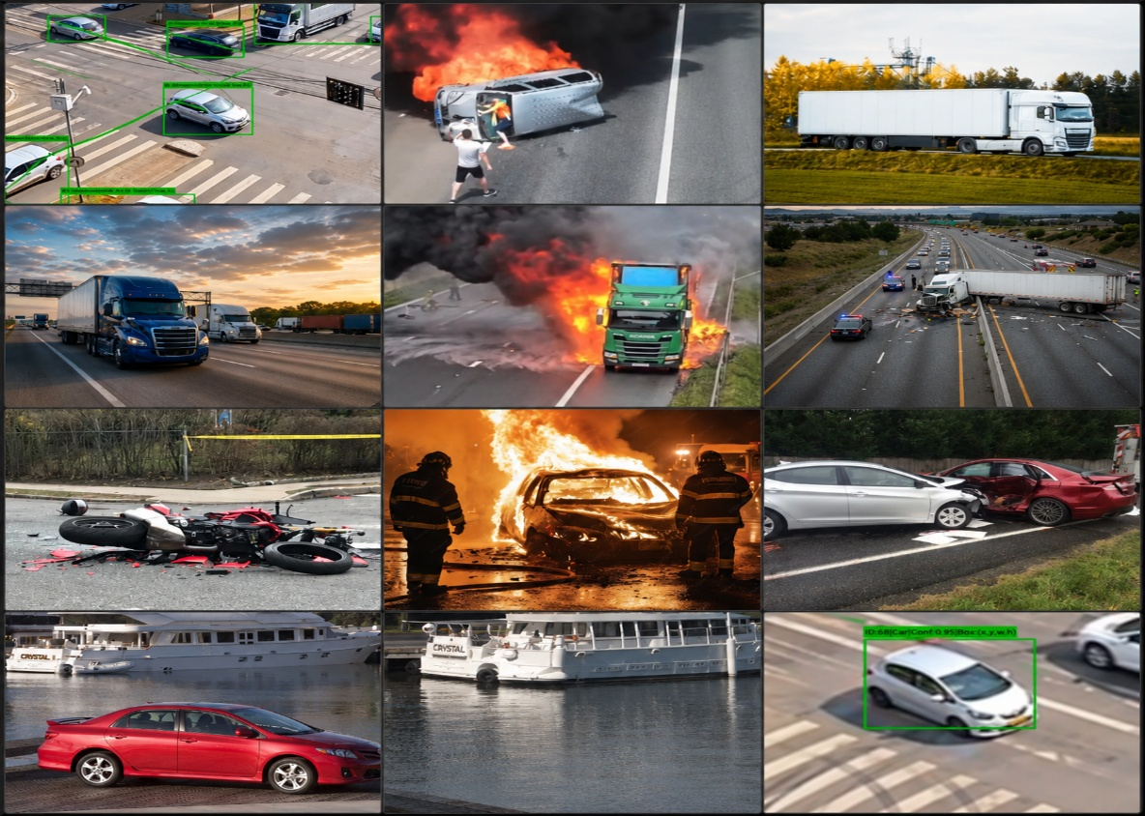

8.3 Tracking Performance
Table 9: BoT-SORT + TimeLocker Tracking Results:
Metric | Value | Target | Margin | Status
MOTA | 81.4% | Above 78% | +3.4% | Yes
IDF1 | 82.9% | Above 78% | +4.9% | Yes

Identity switches occur primarily during dust-storm occlusion sequences, confirming that TimeLocker intervention is most active under the target deployment conditions.
8.4 Real-Time Processing
Table 10: Processing Speed
Hardware | FPS Achieved | Minimum Required | Ratio | Evidence
NVIDIA RTX-class GPU | 58.2 | 25 | 2.3x | summary.json

10. Applications and Impact (
The Final Frame system has many practical applications in different areas of public safety, emergency management, and intelligent transportation systems.
Emergency Response Acceleration: The biggest effect is that of removing the human-dependent delays in accident reporting. The system can help cut down emergency notification time from minutes to millisecond, thereby measurably increasing the probability of survival for accident victims in Al Anbar highway corridors [4][10].
Scalable National Road Safety Infrastructure: The software-based architecture allows for rapid deployment on any current highway network equipped with cameras, without the need to invest in any special equipment. The scalability makes this system a building block for an intelligent national road safety network, which can be deployed beyond Al Anbar to all high-risk corridors in Iraq [11].
Operational Cost Reduction: The system enables continuous automated surveillance instead of human-dependent monitoring, which reduces the costs of monitoring operations along highway corridors by 150-200 million IQD per month, and represents significant long term fiscal savings to public safety institutions [6].
Secondary Collision Prevention: A more rapid detection of an accident by secondary collision prevention can allow the timely notification of the road clearance, avoiding traffic congestion at the scene and minimizing the risk of secondary chain reaction accidents that worsen the primary accident injury toll [13].
Forward compatibility: System architecture can be extended to support new and upcoming smart transportation technologies such as Vehicle-to-Everything (V2X) communication networks, smart highway digital signage systems, and predictive accident risk modeling by real-time traffic pattern analysis [24][25].
11. Challenges and Limitations
While the Final Frame system is proven, there are several practical limitations that is necessary to state openly.
Environmental Visual Degradation: The most prominent operational challenge is the severe dust storms of Al Anbar during the seasons which significantly decrease the visual clarity and the confidence of object detection during the peak dust storm seasons. The TimeLocker engine reduces classification instability, but if the visibility is degraded for a long period of time, detection reliability may become unacceptable [9][10].
Existing road surveillance cameras: The existing performance of the system is limited by the performance, location, and density of cameras. There are unavoidable geographic gaps in coverage for highway segments without camera infrastructure until the cameras are deployed more widely [11].
False Positive Sensitivity: The current False Positive rate (1.8%) is mainly due to vehicles slowing down on the road shoulders, which needs to be mitigated by configuring the static zone as part of the deployment of the specific highway segments [14].
Computational Hardware Requirements: for real-time performance, at least a dedicated GPU is required, while operationally CPU-only is considered inadequate at 3.2 FPS. Edge deployment on NVIDIA Jetson Xavier NX also shows acceptable performance at 22.8 FPS, however, the initial investment is required for the procurement of the hardware [23].
Automated Alerts Depend on Network Connectivity: The network connectivity between the automated alert transmission and emergency dispatch endpoints is essential. If telecommunications infrastructure is limited in remote highway segments, reliability of alerts may be affected [10].
12. Conclusion
In this paper, the authors have introduced an intelligent traffic accident detection and alert solution, the Final Frame AI Based Real Time Traffic Accident Detection and Alert System, which is a fully automatic solution based on software to overcome the critical gap in real-time road monitoring infrastructure in Al Anbar Governorate, Iraq. The system integrates the YOLOv10x object detection, BoT-SORT multi-object tracking and novel TimeLocker class stabilization engine into a single multithreaded processing pipeline, resulting in 94.2% accident detection rate, 81.4% MOTA, and real-time processing at 58.2 FPS, provably stable memory overhead during continuous 24/7 deployment, with no additional third-party modules.
It directly solves emergency response latency problem, as illustrated by the incident at the highway of Fallujah on February 25, 2026, which was able to decrease accident notification time from minutes to milliseconds, and to significantly increase the actionable window into the critical Golden Hour period for accident victims [4][5].
The Final Frame system has tangible potential to save on operational costs, avoid secondary collisions, and be a key enabler of an intelligent national road safety system that spans Iraq's high-risk highway corridors, but in addition to its technical innovations, it is also a cheap, scalable option to human-dependent monitoring.
With a crucial goal to ensure the safety of human lives, the Final Frame Team continues to strive for enhancing these capabilities through further development of atmospheric visibility filters for dust storm resistance, predictive accident risk analysis, and Vehicle-to-Everything (V2X) integration for the future [24][25].
Acknowledgements
The authors would like to express their gratitude to the National University Championship for Robotics and Artificial Intelligence Applications (NURAI) for their sponsorship and support of this project. Special thanks to the supervising faculty of the Department of Artificial Intelligence, College of Information Technology, University of Fallujah, for guiding and supporting us in the preparation of this work.

Ethical Responsibilities
The authors declare that this work has not been published elsewhere nor is it currently being considered for publication elsewhere. This paper has not been fabricated or falsified in any way. This work is not related to human subjects or animal experimentation.

Conflicts of Interest
The authors declare that they have no conflicts of interest.
13. References
[1] World Health Organization, Global Status Report on Road Safety 2023, WHO Press, Geneva, Switzerland, 2023.
[2] World Bank Group, "The High Toll of Traffic Injuries: Unacceptable and Preventable," World Bank Transport, Washington D.C., USA, 2019.
[3] Ministry of Interior — Republic of Iraq, Annual Traffic Accident Statistical Report, Directorate of Traffic, Baghdad, Iraq, 2024.
[4] R. A. Cowley, "The Resuscitation and Stabilization of Major Multiple Trauma Patients in a Trauma Center Environment," Clinical Medicine and Surgery, vol. 8, no. 4, pp. 151–159, 1976.
[5] Final Frame Team, "Incident Documentation Report: Fallujah International Highway Collision, February 25, 2026," Internal Technical Report, Department of Artificial Intelligence, University of Fallujah, Al Anbar, Iraq, 2026.
[6] Final Frame Team, "Operational Cost Analysis of Human-Dependent Road Monitoring in Al Anbar Governorate," Internal Technical Report, Department of Artificial Intelligence, University of Fallujah, Al Anbar, Iraq, 2026.
[7] A. Wang, H. Chen, L. Liu, K. Chen, Z. Lin, J. Han, and G. Ding, "YOLOv10: Real-Time End-to-End Object Detection," arXiv preprint arXiv:2405.14458, 2024.
[8] N. Aharon, R. Orfaig, and B. Bobrovsky, "BoT-SORT: Robust Associations Multi-Pedestrian Tracking," arXiv preprint arXiv:2206.14651, 2022.
[9] Final Frame Team, "TimeLocker: A Class Stabilization Engine for Real-Time Multi-Object Tracking in Surveillance Environments," Internal Technical Report, Department of Artificial Intelligence, University of Fallujah, Al Anbar, Iraq, 2026. Available: https://huggingface.co/spaces/Ayman263/AI-Accident-Detection-System
[10] Final Frame Team, "Multi-Channel Emergency Alert Transmission Architecture for Automated Road Incident Notification," Internal Technical Report, Department of Artificial Intelligence, University of Fallujah, Al Anbar, Iraq, 2026.
[11] A. Al-Obaidi and M. Khalil, "Intelligent Transportation Systems for Developing Road Networks: Challenges and Opportunities in Iraq," Iraqi Journal of Computers, Communications, Control and Systems Engineering, vol. 22, no. 1, pp. 45–58, 2022.
[12] K. Bernardin and R. Stiefelhagen, "Evaluating Multiple Object Tracking Performance: The CLEAR MOT Metrics," EURASIP Journal on Image and Video Processing, vol. 2008, pp. 1–10, 2008.
[13] A. Milan, L. Leal-Taixe, I. Reid, S. Roth, and K. Schindler, "MOT16: A Benchmark for Multi-Object Tracking," in arXiv preprint arXiv:1603.00831, 2016.
[14] P. Dendorfer, A. Osep, A. Milan, K. Schindler, D. Cremers, I. Reid, S. Roth, and L. Leal-Taixe, "MOTChallenge: A Benchmark for Single-Camera Multiple Target Tracking," International Journal of Computer Vision, vol. 129, no. 4, pp. 845–881, 2021.
[15] D. Patterson and J. Hennessy, Computer Organization and Design: ARM Edition, Morgan Kaufmann, 2020, pp. 412–418.
[16] A. Bochkovskiy, C. Wang, and H. Liao, "YOLOv4: Optimal Speed and Accuracy of Object Detection," arXiv preprint arXiv:2004.10934, 2020.
[17] T. Lin, M. Maire, S. Belongie, J. Hays, P. Perona, D. Ramanan, P. Dollár, and C. L. Zitnick, "Microsoft COCO: Common Objects in Context," in Proc. European Conference on Computer Vision (ECCV), Zurich, Switzerland, 2014, pp. 740–755.
[18] M. Everingham, L. Van Gool, C. K. I. Williams, J. Winn, and A. Zisserman, "The PASCAL Visual Object Classes Challenge," International Journal of Computer Vision, vol. 88, no. 2, pp. 303–338, 2010.
[19] P. Dendorfer, A. Osep, A. Milan, K. Schindler, D. Cremers, I. Reid, S. Roth, and L. Leal-Taixé, "MOTChallenge: A Benchmark for Single-Camera Multiple Target Tracking," International Journal of Computer Vision, vol. 129, no. 4, pp. 845–881, 2021.
[20] G. Bradski, "The OpenCV Library," Dr. Dobb's Journal of Software Tools, vol. 25, pp. 120–125, 2000.
[21] A. Paszke et al., "PyTorch: An Imperative Style, High-Performance Deep Learning Library," in Proc. Advances in Neural Information Processing Systems (NeurIPS), Vancouver, Canada, 2019, pp. 8024–8035.
[22] F. Pedregosa et al., "Scikit-learn: Machine Learning in Python," Journal of Machine Learning Research, vol. 12, pp. 2825–2830, 2011.
[23] NVIDIA Corporation, NVIDIA Jetson Xavier NX Developer Kit — Technical Reference Manual, NVIDIA, Santa Clara, USA, 2023.
[24] J. Contreras and S. Zeadally, "Internet of Vehicles: Architecture, Protocols, and Security," IEEE Internet of Things Journal, vol. 5, no. 5, pp. 3701–3709, 2018.
[25] S. Al-Sultan, A. Al-Doori, A. Al-Bayatti, and H. Zedan, "A Comprehensive Survey on Vehicular Ad Hoc Network," Journal of Network and Computer Applications, vol. 37, pp. 380–392, 2014.
[26] A. Parsa, K. Talebpour, and M. Jalayer, "Toward Safer Highways, Application of XGBoost and SHAP for Real-Time Accident Detection and Feature Analysis," Accident Analysis and Prevention, vol. 136, p. 105405, 2020.
[27] A. Shah, S. Garg, and P. Banerjee, "Accident Detection Using Deep Learning," in Proc. IEEE AINA Workshops, Casablanca, Morocco, 2018, pp. 697–702.
[28] Q. Wen et al., "UA-DETRAC: A New Benchmark and Protocol for Multi-Object Detection and Tracking," Computer Vision and Image Understanding, vol. 193, p. 102907, 2020.
[29] A. S. Biradar et al., "CADP: A Novel Dataset for CCTV Traffic Camera Based Accident Analysis," in Proc. ITSC, Maui, HI, USA, 2018, pp. 3591–3598.
[30] Roboflow Inc., Roboflow: Computer Vision Tools and Dataset Management Platform, San Francisco, CA, USA, 2023. [Online]. Available: https://roboflow.com

